‘biocharBBQ’ carbon monoxide safety test

Method.

A ‘biocharBBQ’ was placed within an open-fronted shed. A CO monitor was placed directly above the flue outlet at a distance of 55cm. The ‘biocharBBQ ‘was operated for 42 minutes and used to cook a meal in order to mimic normal use. There was no draft, so the monitor was enveloped in the fumes from the ‘biocharBBQ’.

Results.

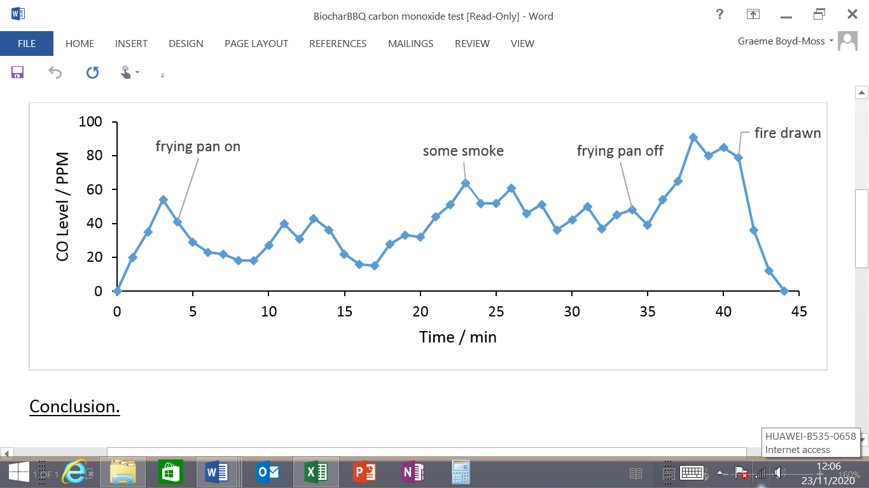

Conclusion.

The average CO level was 41 PMM. As it is extremely unlikely that anyone will stand with their face directly above the ‘biocharBBQ’ for an extended period, these levels would be acceptable. However the results confirm that the ‘biocharBBQ ‘must only be operated in well ventilated spaces. They also show that visible smoke contains higher concentrations of CO than clean vapour. In this instance the smoke was caused by fresh wood being added too late. The results also show that exhaust vapour is dispersed by the introduction of a cooking utensil. Breathing directly above the open flue should be avoided.